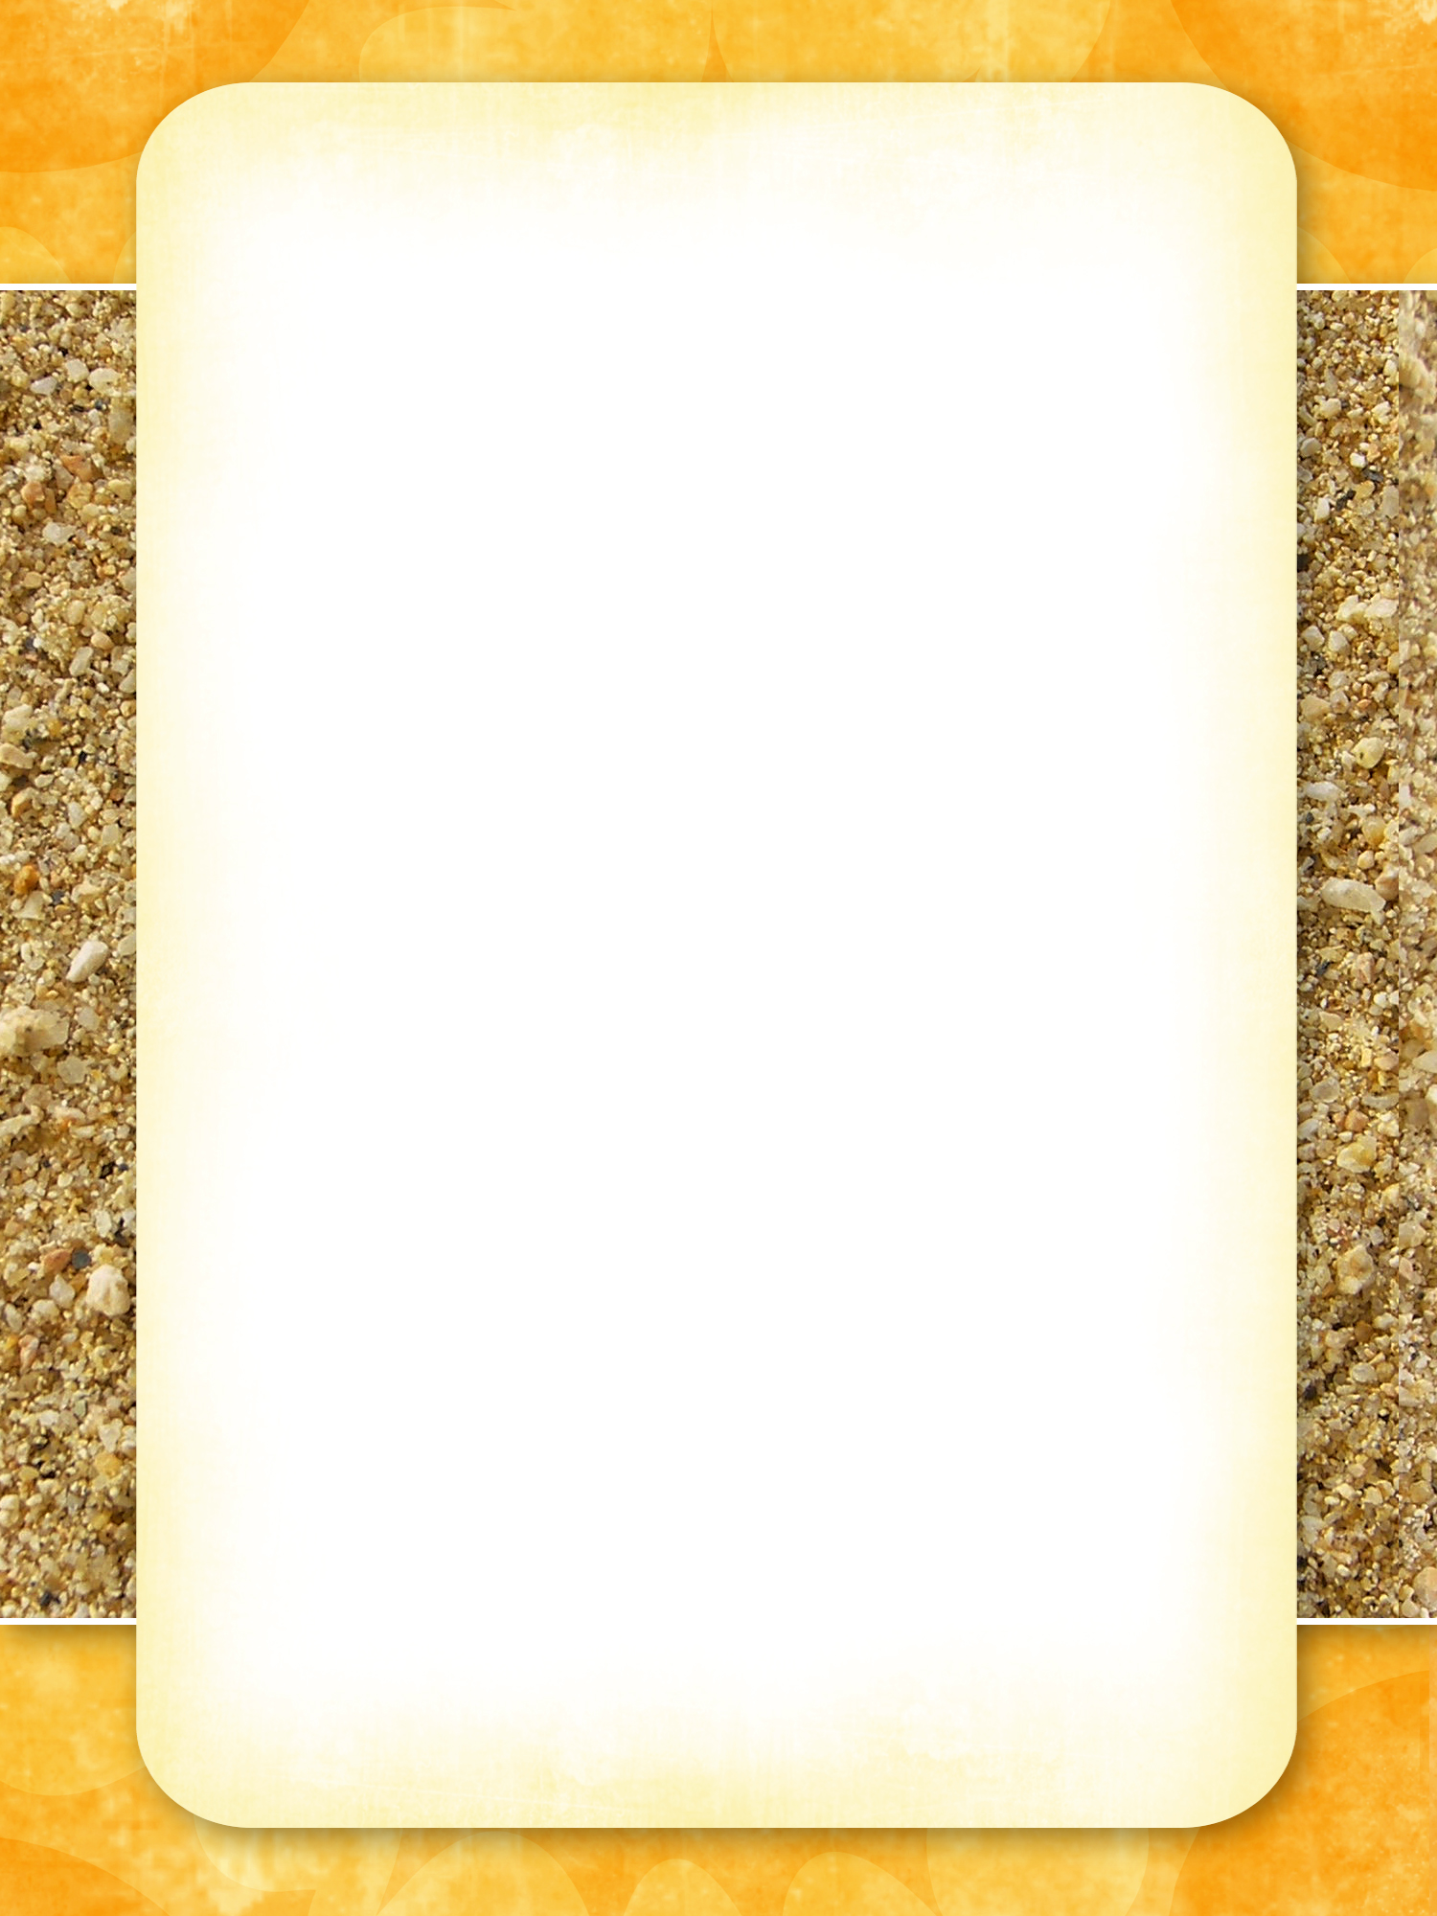

# Valhalla der drachen

2017

# Menu

Valhalla der Drachen will provide (highlighted in BLUE).

Plates, solo cups, napkins, silverware, serving and cooking utensils and knives.

Breakfast Friday, Saturday and Sunday (bacon, sausage, eggs, country gravy, muffins, toast, fruit or berries).

## Friday 8-4

VdD - Breakfast

Lunch – Wing-it(burgers & brats, side to share?) and VdD Dragon Beans.

Supper - bring something to grill and a side dish to share.

Cheesy hash browns, personal cast iron pies

Smores

## Saturday 8-5

Breakfast

Lunch - bring something to grill and side to share. and VdD Dragon Beans.

Supper - Smoked Prime Rib of Dragon, baked sweet potatoes and side to share.

Smores

## Sunday 8-6

Breakfast

Lunch – Wing it(left overs?)